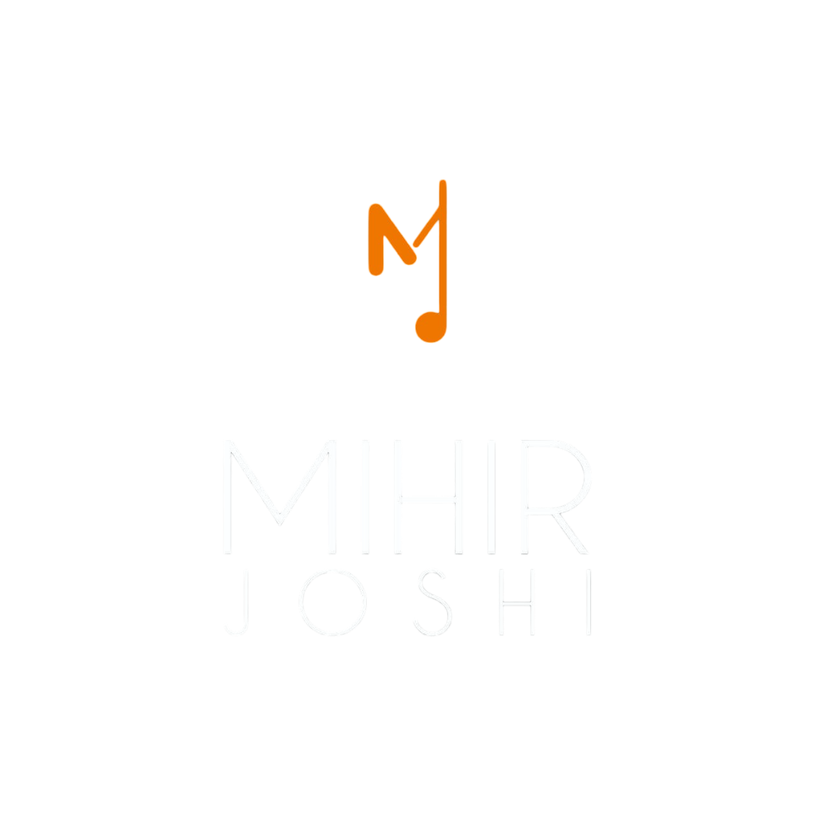

TECH RIDER – BOLLYWOOD GARBA NIGHT

Musicians & Instruments

Musician | Instrument
Singer 1 | VOCAL
Singer 2 | VOCAL
Percussion 1 | DHOL
Percussion 2 | DHOL
Rhythms 1 | OCTOPAD
Rhythm 2 | DRUMMER
Rhythm 3 | DRUMMER
Instrument 1 | GUITAR
Instrument 2 | KEYBOARD

DI & Mic Requirements
- 5 DI (MONO)
- 3 DI (L&R)
- 2 CORDLESS MIC SHURE/SENNHEISER G4
- 2 DRUMS MIC KITS ( FOR DRUMS )
- 4 SM57 CADROID ( FOR DHOLS )
- 1 SM58 & 1 SAMSON CO2 (TALK BACK 1 SM58)
- MIC STANDS ( 2 BIG AND 4 SMALL )
- EXTENSION BOXES

Stage & Sound Setup
- 16 X 40 STAGE SIZE WITH DECORATIVE BACKDROP/LED SCREEN
- RAMP 4 × 6 for Singer
- PAR LIGHTS - SHARPY - VFX ACCORDINGLY TO THE STAGE

Sound Arrangements
- 8 LINE ARRAY VRX
- 4 BASS
- 6 MONITORS VRX
- 2 IN-EAR MONITORS (SENNHEISER-G3/G4)
- 2 SIDE FILLS
- 2 SUB BASS

Notes
- WE REQUIRE AT LEAST 1 HOUR FOR THE SOUND CHECK.
- SOUND CHECK MUST BE COMPLETED 1 HOUR BEFORE THE PERFORMANCE STARTS.
- THERE MUST BE A QUALIFIED SOUND ENGINEER.
- FOR ANY CHANGES IN THE ABOVE TECHNICAL RIDER, PLEASE CONFIRM SAME WITH THE BAND.
- CONTACT: MIHIR JOSHI (7448096356 / 9022198587).

